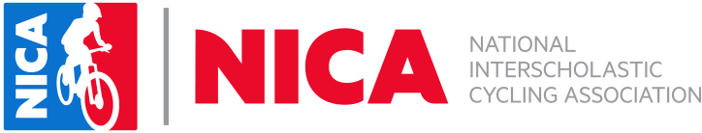

Student-Athlete Code Of Conduct

I acknowledge I will review this code of conduct with my Student-Athlete and they will follow the NICA Rules and Guidelines as additionally described in the NICA handbook. I also understand that failure to do so may lead to his or her suspension or expulsion from national and/or state league activities.

_________________________________________
Student Name

__________________________________________
Parent Name

___________________________________________ _________________
Parent Signature Date

